Week 2 – Create Groceries App

Home.Html tab:

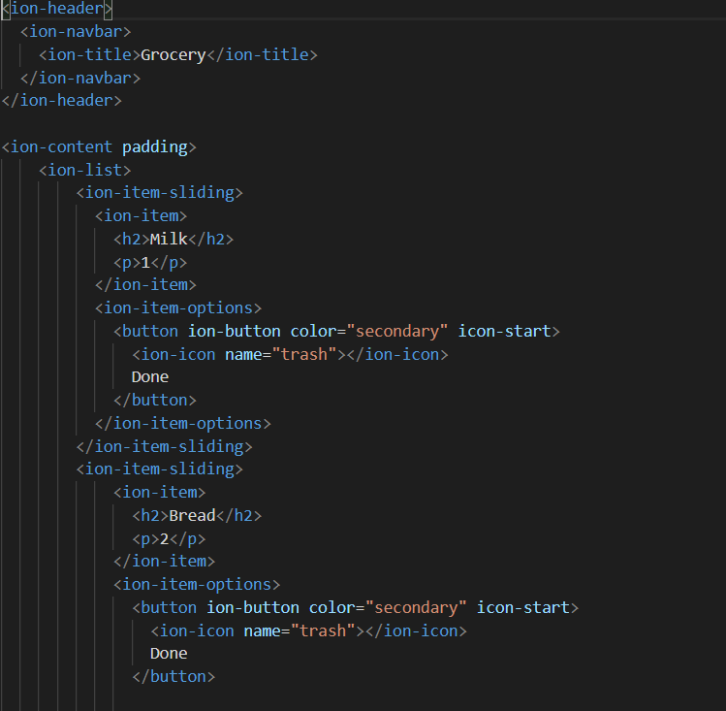
This is to create a list in Ionic. As requested by assignment 2, additional added items includes fruit, cleaning supplies, pet food, shampoo, and megazines. This will show on the shopping cart icon which serves as the first tab of information to groceries.

App.module.ts:

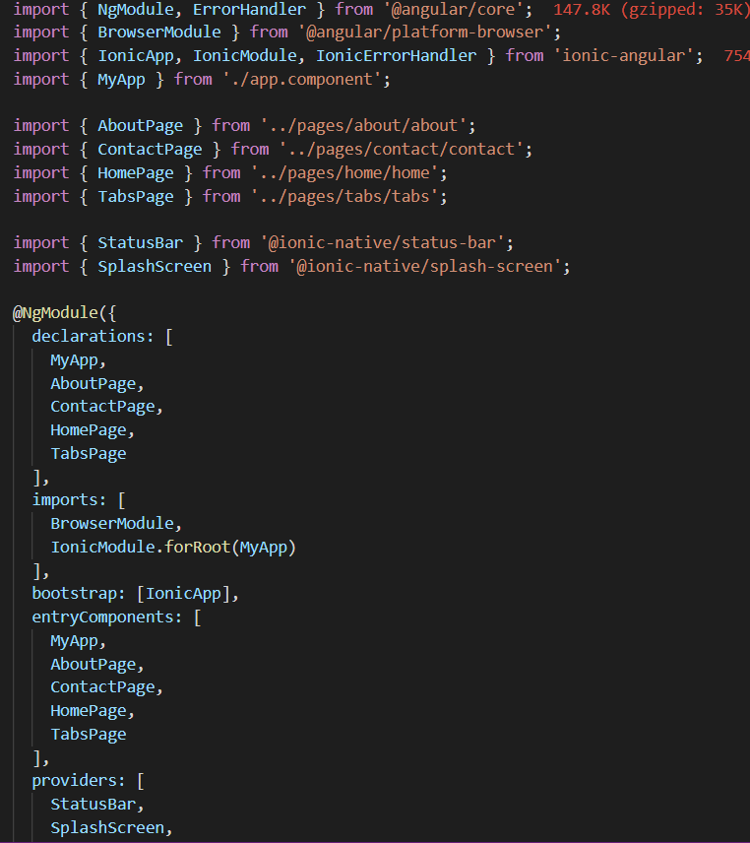
Lazy loading from all the HTML pages need to be included to make the webpages useable in the application.

Home.ts:

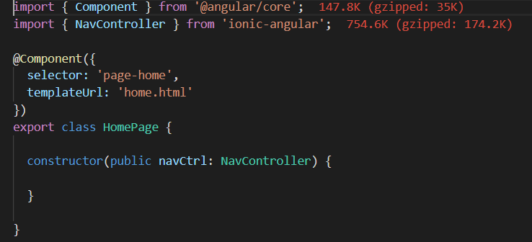
The home.ts includes the component as a construct to view the styles for inputs and outputs. This specific typescript. In this script, home.ts is designating the format and template as home.html. It’s wrapped as a string to signify it as a variable being passed.

About.Html:

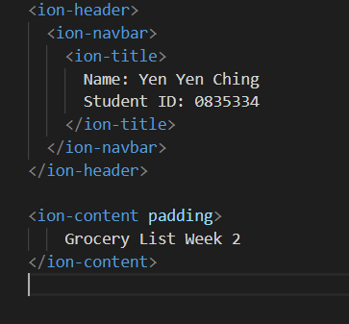

The About.Html will show the student name and id, as well as information on the second tab, “About”.

Contact.Html:

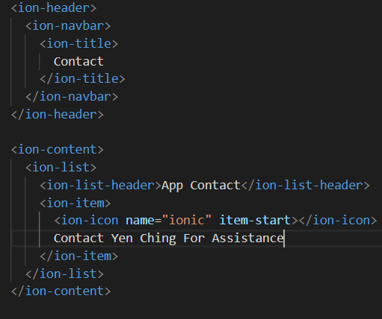

Contact.Html will show on the third tab with information on who to contact for the App.

Node.Js Console Commands:

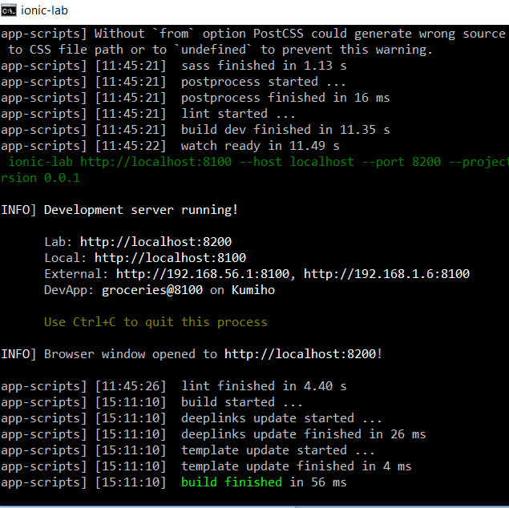

After installing ionic, “ionic serve –lab” will be entered so we can check all three devices to see how the display is on IOS, Android, and Windowns. After http://localhost:8200 is entered into browser, you’ll see the following output below.

